Matlab Part:

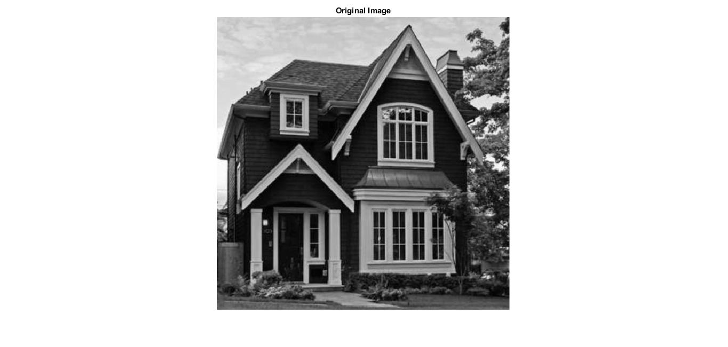

Deteriorated Image, Increasing of all pixels belonging to columns that their index is an integer multiplication of 16 by 40 gray levels:

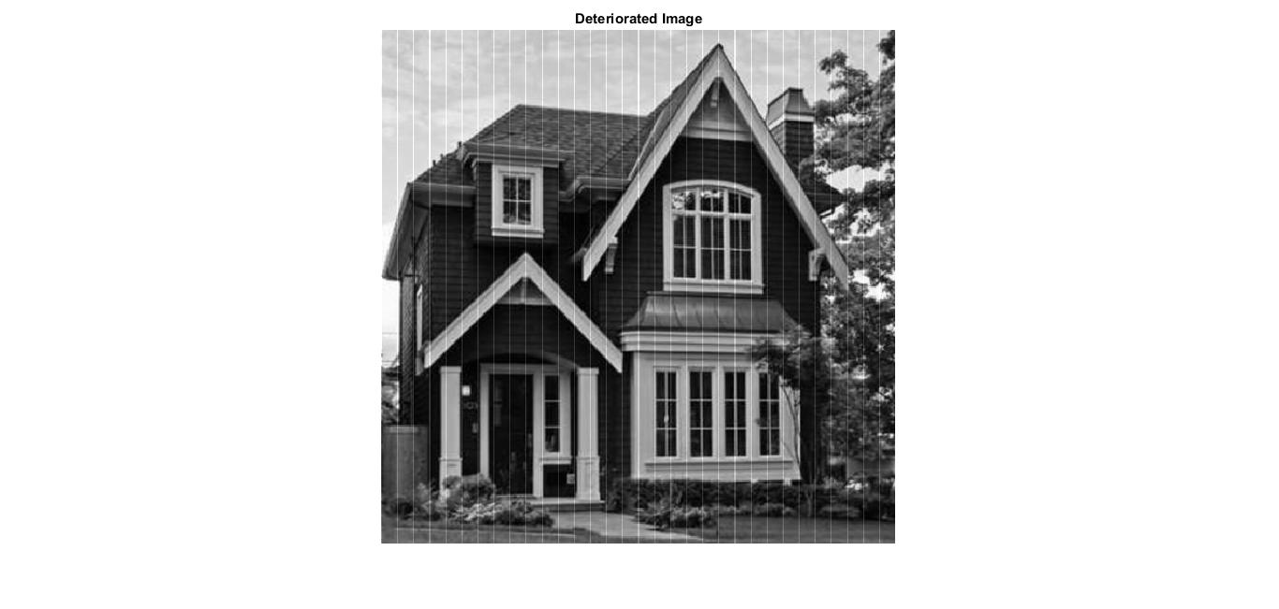

1. According to question 5 the transform of the interference is $cT=N→c=\frac{N}{T}→c=\frac{512}{16}=32$:

$$40*\left[\begin{matrix}c \\ 0 \\ ⋮ \\ c \\ 0 \\ ⋮ \\ ⋮ \\ 0\end{matrix}\right]=40*\left[\begin{matrix}32 \\ 0 \\ ⋮ \\ 32 \\ 0 \\ ⋮ \\ ⋮ \\ 0\end{matrix}\right]=\left[\begin{matrix}1280 \\ 0 \\ ⋮ \\ 1280 \\ 0 \\ ⋮ \\ ⋮ \\ 0\end{matrix}\right]$$

Matlab results:

DFT components in which the iterference have strictly positive values: 0 32 64 96 128 160 192 224 256 288 320 352 384 416 448 480

The value of each positive components is: 1280

The value of all other components is: 0

We can see that the result of the calculations match the theoretical result.

c.

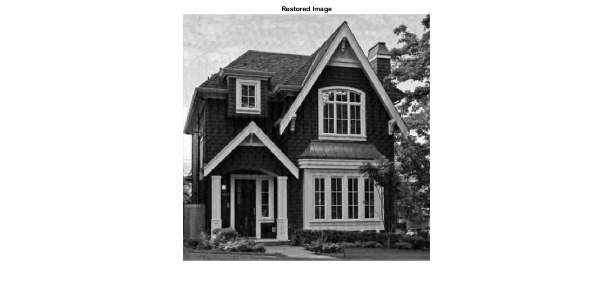

MSE of the deteriorated image: 97.8059

MSE of the restored image: 22.6476

As expected, the MSE of the restored image is much lower than the MSE of the deteriorated image. In the restored Image we barely see defects.